**ZENFLOW WEBSITE PROJECT DOCUMENTATION**

**=====================================**

Student Information:

- Name: Mohammad Hamed Alharbi

- ID: 2240738

- Section: CS1

**PROJECT OVERVIEW**

**================**

Website Name: ZenFlow

Domain: Digital Wellness & Meditation Platform

Target Audience: Busy professionals, wellness enthusiasts, and individuals seeking mental health

support

**1. IDEA DEVELOPMENT**

**==================**

Problem Definition:

In today's fast-paced digital world, stress, anxiety, and mental health challenges have become increasingly prevalent. Many individuals struggle to find accessible, high-quality meditation and mindfulness resources that fit into their busy schedules. Traditional meditation classes are often expensive, time-consuming, and not always available when needed. There's a significant gap in the market for a premium, user-friendly digital wellness platform that provides personalized meditation experiences, sleep support, and stress management tools.

Recommended Solution:

ZenFlow is a premium digital wellness platform that offers comprehensive meditation and mindfulness services through an elegant, user-friendly website. Our solution addresses the modern need for accessible mental wellness tools by providing:

- Guided meditation sessions for all skill levels

- Sleep stories and relaxation techniques

- Stress management and breathing exercises

- Corporate wellness programs

- Personal coaching services

- Flexible scheduling and on-demand access

Benefits of the Provided Solution:

1. Accessibility: 24/7 access to wellness resources from any device

2. Personalization: Tailored meditation experiences based on individual needs and skill levels

3. Convenience: No need to travel to classes or adhere to fixed schedules

4. Cost-Effectiveness: More affordable than traditional therapy or meditation classes

5. Proven Results: Science-based methods with measurable outcomes

6. Community Support: Access to a supportive community of like-minded individuals

7. Professional Guidance: Expert instructors and wellness professionals

8. Flexibility: Sessions ranging from 3 minutes to 60 minutes to fit any schedule

**2. WEBSITE STRUCTURE**

**===================**

The ZenFlow website consists of 6 main pages:

1. Homepage ï¿½ The main landing page introducing visitors to ZenFlow through the Hero Section, Features Section, Statistics Section, Testimonials Section, and a Call-to-Action Section.

2. Services - Provides a detailed overview of all wellness services offered, featuring a Page Header, a comprehensive Services Grid, and a Benefits Section highlighting key advantages.

3. Meditation Library - A browseable collection of meditation sessions, organized through a Page Header, Category Filters for easy navigation, and a Meditation Cards Grid displaying available sessions.

4. About Us - Shares the companyï¿½s mission, team, and story through a Page Header, Mission Statement, Team Section, Our Story Timeline, and Core Values Section.

5. Pricing - Presents ZenFlowï¿½s subscription plans and pricing details, including a Page Header, Pricing Plans, Features Comparison, and an FAQ Section to address common inquiries.

6. Contact - Offers multiple ways to connect with ZenFlow, including a Page Header, Contact Information, Contact Form, Social Media Section, and an FAQ Section for user support.

**3. SITE MAP**

**==================**

The sitemap is structured hierarchically, beginning with the Homepage that introduces visitors through key sections such as the Hero, Features, Statistics, Testimonials, and Call-to-Action. From there, users can navigate to the Services Page, which highlights offerings through a Page Header, a detailed Services Grid, and a Benefits Section. The Meditation Library provides categorized access to meditation content through its Page Header, Category Filters, and Meditation Cards Grid. The About Us page focuses on company identity, featuring a Mission Statement, Team Section, Our Story Timeline, and Core Values. The Pricing page outlines various plans, a feature comparison table, and an FAQ section for clarity. Finally, the Contact page concludes the structure, offering essential contact information, a contact form, social media links, and a helpful FAQ to ensure smooth communication.

**4. STORYBOARD**

**==================**

Detailed storyboard design have been created for all 6 pages, including:

- Header with navigation and logo

- Main content sections with proper visual hierarchy

- Footer with links and contact information

- Responsive design considerations for mobile, tablet, and desktop

- Color scheme and typography specifications

- Interactive elements and call-to-action buttons

Connected Storyboard:

https://www.figma.com/design/CD9B0W7xrjLmuIgOnrVn8Z/ZenFlow?node-id=0-1&t=vvZ8CwjBBfngYDPk-1

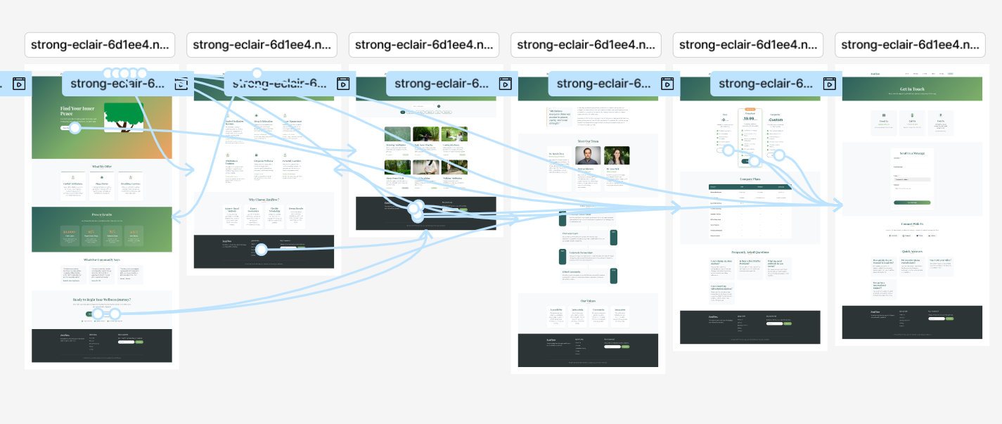

(on Figma, you have to click on the "prototype" button on the right panel, to see the storyboard links)

**5. TECHNICAL SPECIFICATIONS**

**========================**

HTML Requirements:

- DOCTYPE declaration and proper document structure

- Semantic HTML5 elements (header, nav, main, section, footer)

- Proper indentation and commenting

- Meta tags for SEO and responsive design

- External CSS stylesheet linking

- Form elements with proper attributes

CSS Requirements:

- External stylesheet with organized sections

- Responsive design using media queries

- Modern CSS features (flexbox, grid, transitions)

- Premium color palette and typography

- Consistent spacing and layout system

- Hover effects and subtle animations

JavaScript Requirements:

- Minimal JavaScript for mobile navigation toggle

- Smooth scrolling and basic interactions

- Form validation (if needed)

**6. FOLDER STRUCTURE**

**================**

-html/ - had to be unpack to be compatible with Netlify's deployment configuration

- css/ - Contains stylesheet files

- images/ - Contains all website images

- txt/ - Contains text files and documentation

- docs/ - Contains Word documents and project files

**7. DESIGN PHILOSOPHY**

**==================**

ZenFlow follows a premium design philosophy that emphasizes:

- Visual hierarchy through typography and spacing

- Emotional connection through calming color palettes

- User experience through intuitive navigation

- Brand consistency across all touchpoints

- Accessibility and responsive design

- Modern aesthetics that convey trust and professionalism

**8. CONCLUSION**

**==================**

ZenFlow represents a comprehensive solution to modern mental wellness challenges, providing users with accessible, high-quality meditation and mindfulness resources through a beautifully designed, user-friendly website. The project demonstrates proficiency in web development, design principles, and user experience considerations while addressing a real-world need in the digital wellness space.